Seaview Community Elementary School
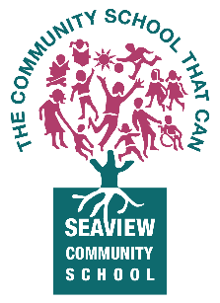
School District No. 43 (Coquitlam)
1215 Cecile Drive, Port Moody, B.C. V3H 1N2
Phone: (604) 936-9991 Email: seaview@sd43.bc.ca

February 16, 2026

Good morning Seaview Families! We hope you were able to enjoy the wonderful weather we had the last couple of days. Now we (maybe it is just me.. ) hope that any snow stays on the mountains! I have been at Seaview for 2 weeks now and I have to say that this is such a fabulous community- a hidden gem! I am slowing learning the students and staff names and working on getting to know the “Seaview Way” of doing things. My door is always open if there are any questions or if you just want to say hi!

This past week has brought up many emotions to our community. We want to reaffirm that Coquitlam Schools are committed to ensuring that we are creating inclusive spaces where everyone feels a sense of belonging. There is no place for hatred in our workplace, our schools, or our classrooms. Please know every effort is being made across the district to support all staff, inform and educate students, and share tools and resources with partners. All of this is intended to provide a clear and unified response to support the grieving process, to address misinformation, and to support our communities.

Traffic Safety:
There has been some concerns regarding the traffic safety around our community streets. The City has said to us that they will be conducting study in 2026. The purpose of this study is to review and provide recommendations to address active transportation barriers and challenges, traffic safety concerns, traffic calming needs, and opportunities for infrastructure improvements. The study will also focus on improving the pedestrian experience around the school. Please continue to drive slowly through our community streets.

Happy Year of the Horse! Lunar New Year is on February 17, 2026, with many families enjoying a huge feast the night before. Lunar New Year is considered the biggest annual event in many Asian cultures and is celebrated widely in Asia: China, Korea, Vietnam, and others. For all, this is a year of rapid change and transformation, characterized by optimism, action and a strong drive for personal growth.

Ramadan begins on February 17, 2026. Our focus is on supporting students’ well-being and fostering belonging please let your child’s teacher know if there may be some changes in their daily routines such as energy levels, eating schedules, and family responsibilities, simple cultural acknowledgment helps ensure students feel understood and supported. Thank you!

Important Upcoming Dates
Feb. 16 | BC Family Day (schools closed)
Feb. 19 | Make up Hearing assessment for those who missed  February birthday celebrations
Feb 20 | Assembly – Celebration of learning (Div 2,4,6,8) 9:30 – 10:00
Feb. 23 | PAC Meeting (630pm start)
Feb. 25 | Pink Shirt Day
Feb. 27 | Pro D Day
March 16-27 | Spring Break

Information & Dates for SD43 Programs

Summer Learning! Please note that once you register, there will be lotto system of acceptance. APRIL 2-8 is the registration.

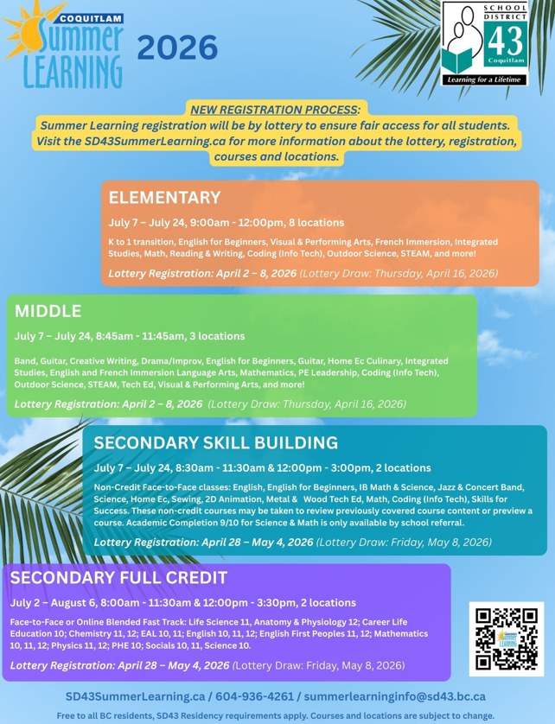

Know any pre-Kindergarten’s? Let them know they can still register for next year!
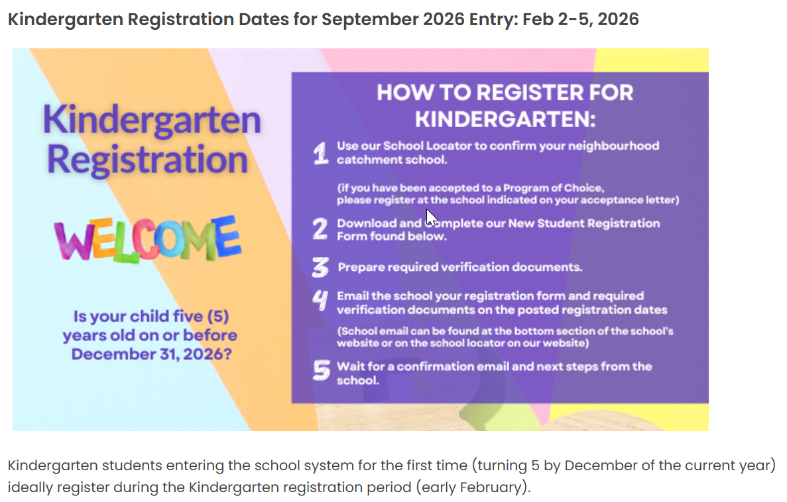
More details on the district website:
- https://www.sd43.bc.ca/Programs/Pages/default.aspx#/=
- https://www.sd43.bc.ca/Schools/Registration/Pages/default.aspx#/=


Seaview Yearbook Cover Contest

Due: February 27, Friday (end of day!)
Needs full school name and year:
- Seaview Community School
- 2025-2026
Size: 8 ½” x 11” (or your picture will be partially cut off if a bigger size)
Place your name and division on the back of your entry.
Hand into the office By February 27!!

From The Seaview PAC
Don’t miss out on a hot lunch – order today!

ORDER: Order deadlines are always the Friday before at 11:59pm. For better success, pre-order for all hot lunches NOW. The ordering system is all online through:
Returning users: Order on Munch-a-Lunch here
→ New to Munch-a-Lunch? Start Here
Detailed instructions found in here.
Now accepting orders through June! Check out this exciting line-up:
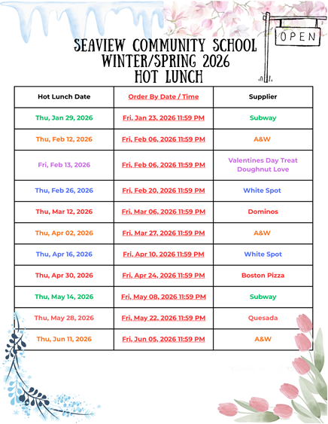
VOLUNTEERS NEEDED: On the day of, a small group of parents help coordinators organize meals and deliver to each classroom. Great way to make connections in our community. Watch children's faces light up with joy!! WIN WIN. Please sign up on MunchALunch under Volunteer!
Questions?? contact hotlunchseaview@gmail.com
Thanks,
Seaview PAC Sponsored Hot Lunch Team

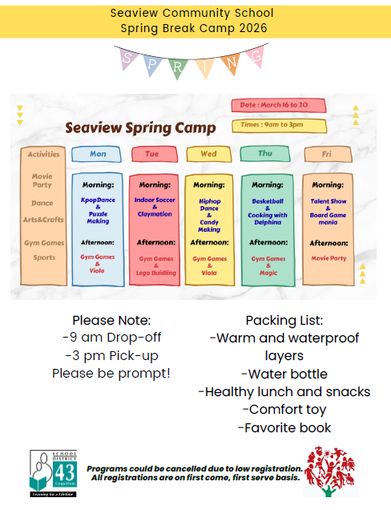


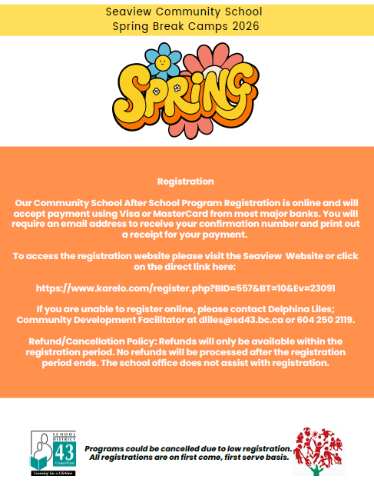


Ways To Support Your PAC’s Fundraising Effort in Your Community

https://pedalheads.com/en/british-columbia Use promo code SEAVIEW26 to receive $25 off your registration for all available lessons and camps through June 20, 2026. Pedalheads will also donate $25 to the Seaview PAC every time the code is used.



Bag your returns in clear, plastic bags. Drop off at any Encorp Return-It. You can donate your account funds to Seaview Community School PAC using the link here.


www.firstaidhero.com Authorized Red Cross Training Partner
Ongoing courses offered on various days.
*Stay Safe Course: 9-13 years
*Babysitting Course: 11-15 years
Online courses earn $8 towards our PAC.
Use promo code: Seaview


Port Moody Liquor Store Visit the Port Moody Liquor Store (at the corner of St. Johns and Williams St.) and mention Seaview Community School when making a purchase. They will donate 5% of the sale back to our PAC.


www.rvnwellness.com Use promo code SEAVIEW for 5% off any class or children’s weekly program or retail purchase and 10% of your total purchase will be donated back to Seaview PAC. Use promo code SEAVIEW5 for 5% off any monthly membership and 10% will be donated back to Seaview PAC. Not valid for specialty classes or counselling.

In The Community
